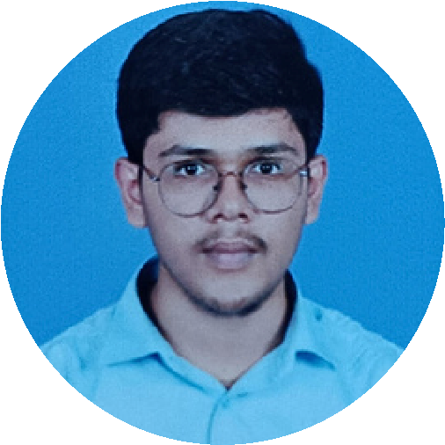


TECHNICAL SKILLS
c
java
React.js
MongoDB
TOOLS AND TECHNOLOGIES
HTML

CSS
Figma
Canva
Proteus
KiCad
https://www.linkedin.com/in/
sanjayram-a-m-5a084725b/
https://github.com/Sanjayram6379
SANJAYRAM A M

ELECTRONICS AND COMMUNICATION ENGINEERING
PROJECTS
EDUCATIONAL BAGROUND
Career Objective
To
establish
a
successful
career
in
electronics,
communication,
and
software
by
leveraging
my
skills
to
contribute
to
innovative
projects,
adapt
to
emerging
technologies, and drive organizational growth. I am committed to continuous learning,
taking on challenging responsibilities, and striving for excellence to achieve a higher
position and make a meaningful impact on the company's success.
CONTACT
6379610284
Sathyamangalam-638401
sanjayram.ec22@bitsathy.ac.in
DEGREE - BANNARI AMMAN INSTITUTE OF TECHNOLOGY(2022-2026)

B.E - ELECTRONICS AND COMMUNICATION

ENGINEERING

CGPA:8.32(up-to 5th semester)
12
(2022)
TH - BANNARI AMMAN VIDYA NIKETAN

%
92.50
(2020)
TH - BANNARI AMMAN VIDYA NIKETAN
10

%
92
DURATION

:
Aug 2023- Oct 2023
ROLE PLAYED :
Hardware integration
TITLE

:

Cloud Based weather Monitoring
DISCRIPTION

:
A
cloud-based
weather
monitoring
system
measures
environmental parameters using sensors and controls actuators like fans, heaters,
and humidifiers based on real-time data. The system ensures efficient climate
management by sending alerts and reports via the cloud.
TEMSIZE

:
2
TITLE

:
Aquatic Recommendation and Monitoring System
DURATION

:

Jun 2024 - Aug 2024
DISCRIPTION

:
Developed
a
web-based
solution
for
monitoring
water
parameters like temperature, pH, and salinity. Provided fish recommendations
based on real-time input and set alert systems for threshold breaches. Used
technologies like Vue.js for frontend and Node.js for backend.
TEMSIZE

:

3
ROLE PLAYED :
Front end (React.js), Hardware Setup
TITLE
DURATION

:

Inventory System
:
Nov 2024 - Jan 2025
TOOLS USED

:

React.js, node.js and MongoDB
DISCRIPTION
:

The
Inventory
System
is
a
software
project
designed
to
efficiently manage and store records of sold, available, and purchased items. It
provides
a
user-friendly
interface
for
tracking
inventory
levels,
ensuring
real-
time updates, and generating detailed reports for streamlined operations.
LANGUAGES
English (R,W,S)
Tamil (R,W,S)
Kannada (S)
PERSONAL INFORMATION
DATE OF BIRTH : 15 JANUARY 2005
NATIONALITY : INDIAN

FATHER'S NAME : MAHESWARAN N
MOTHER'S NAME : MAHESHWARI A M

HOBBIES
utdoor activities
0

Drawing

Travelling
PERSONAL SKILLS
Time Management

Leadership

Teamwork

Adaptability

I
SANJAYRAM
A
M
,
hereby
declare
that
the
above
written particulars are true to the best of my knowledge
Signature
DATE :

PLACE : SATHYAMANGALAM
AREAS OF INTEREST
Mathematical and Logical
Problems solving
Learning new Emerging
Technologies

Cloud Integration
DECLARATION
CO-CURRICULAR ACTIVITIES
1
.GENESIS 2K24-PAPER PRESENTATION
Participated in the GENESIS 2K24-PAPER PRESENTATION
Event,
an
National
Technical
Symposium
organized
by
:
SRI
RAMAKRISHNA
ENGINEERING COLLEGE (SREC),COIMBATORE held on

7
th November
2024.
2
.AAKRUTI GOLBAL
2024
Participated
in
the
AAKRUTI
GLOBAL
2024

Event,
a
National
Technical
Symposium
organized
by
MIT
Academy
of
Engineering,
Pune,
held
on
15
th
October 2024.
. INTERNATIONAL CONFERENCE ON CURRENT TRENDS IN
3
MODERNIZED COMPUTING AND COMMUNICATION
TECHNOLOGIES MCCT-2023
Participated
in
the
International
Conference
on
Current
Trends
in
Modernized
Computing
and
Communication
Technologies
(
MCCT-2023),
organized
by
the
Department
of
Augmented
Reality
&
Virtual
Reality,
Institute
of
Computer
Science and Engineering, SIMATS Engineering, Chennai, held on 11th October
2023.
TH INTERNATIONAL CONFERENCE ON EMERGING TRENDS
4.5
IN ENGINEERING AND TECHNOLOGY -ICETET 2023
Participated
in
the
th
5
International
Conference
on
Emerging
Trends
in
Engineering and Technology (ICETET-2023), organized by St. Joseph College of
Engineering, Chennai, held on 19th and 20th April 2023, and presented a paper
titled "Earthquake Detection System".

